


PE/Sport Premium Report
2023 – 2024



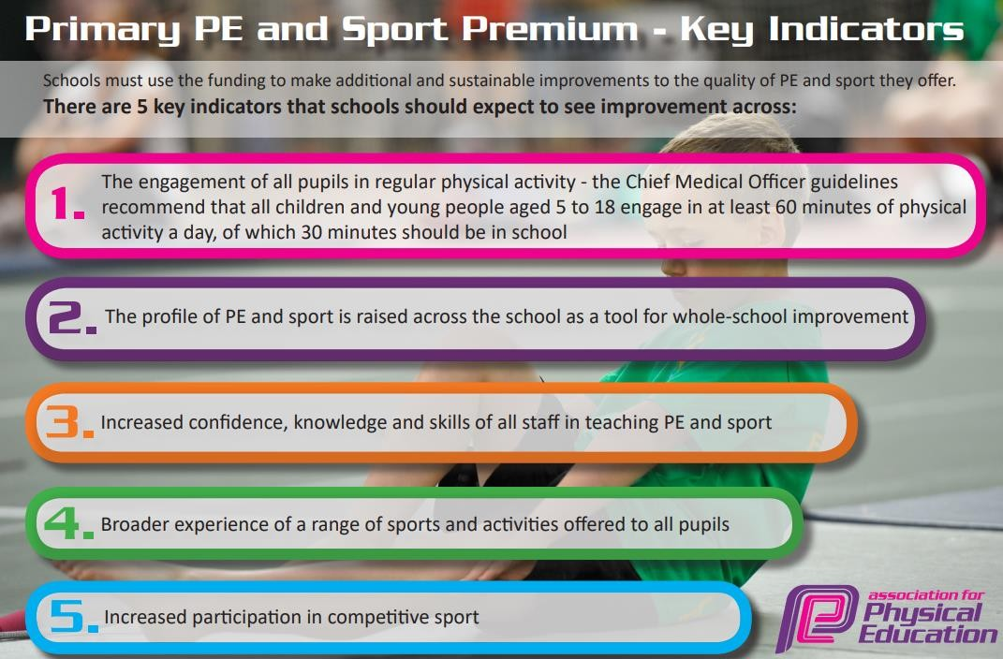

Meeting national curriculum requirements for swimming and water safety.
What percentage of your current Year 6 cohort swim competently, confidently and proficiently over a distance of at least 25 metres?  N.B. Even though your pupils may swim in another year please report on their attainment on leaving primary school at the end of the summer term 2020. | 89%  (41 pupils)
What percentage of your current Year 6 cohort use a range of strokes effectively [for example, front crawl, backstroke and breaststroke]? | 48%  (22 pupils)
What percentage of your current Year 6 cohort perform safe self-rescue in different water-based situations? | 24%  (11 pupils)
Schools can choose to use the Primary PE and Sport Premium to provide additional provision for swimming but this must be for activity over and above the national curriculum requirements. Have you used it in this way? | No

Key achievements to date until July 2023: | Areas for further improvement and baseline evidence of need:
- We have had our most successful swimming year to date.  - Staff have gained confidence in teaching PE through shadowing sports coaches.  - We successfully launched a girl’s football team, and they did very well in matches against other schools.  - We successfully launched a boy’s cricket team with a group of pupils who had never played cricket before.  - There are a range of activities available for pupils to engage in at lunchtimes.  - We have successfully launched a morning activity club with our learning mentor. This is also helping attendance. | - New PE curriculum needs implementing and further embedding. All children now take part in 2 PE lessons per week.  - Staff need training on the assessment of PE skills.  - Revisit and review staff training to ensure staff feel confident in teaching and use the sports coach to enable this.

Action Plan and Budget Tracking
Academic Year: 2022 - 2023 |  | Total fund allocated: £18,500 |  |  | Reviewed:
Intent | Implementation |  | Cost | Impact | Next steps:
Pupils engage in regular physical activity (30 minutes of physical activity a day in school).  - % of pupils achieving ARE in each area PE to increase from last year in every year group.  - % of lunchtime incidents decreases due the engagement in lunchtime programme. | Learning mentor role extended to that of a sports coach during playtimes and lunchtimes. Role includes coordinating the extracurricular programme at lunchtimes.  Continue employment of sports coach to assist with the running of extracurricular lunchtime clubs.  - SM Sports  Employ sports coach to deliver additional PE session with specific year groups.  Purchase new high quality equipment to reinvigorate playtime provision.  Pupils to engage with:  - 2 PE session per week  - 45 minutes of play time each day where physical activity and games are encouraged and facilitated by  Coaches. |  | £11,700– SLA with SM Sports (10 hours per week)  £4000- funding proportion of learning mentor’s salary for lunchtimes and after school clubs.  £3000- sports equipment for clubs

Swimming -  Pupils leave Y6 being able to:  - Perform safe self-rescue in different water based situations  - Swim competently, confidently and proficiently over a distance of at least 25 metres  - Use a range of strokes effectively, for example, front crawl, backstroke and breaststroke. | - Swimming: Y4 - 1 hour session per week for 19 weeks, starting 20th February. | Funded from main school budget.
The profile of PE and sport is being raised across the school as a tool for whole school improvement. | ‘Get Set 4 PE’ assessment framework further embedded to allow clear understanding of ARE in each area of PE, resulting in accurate assessment and precision planning to narrow gaps in ability.  Further develop provision/resources for each of the new PE units and use sports coach modelling to support teachers in their teaching of PE.  Monitor the effectiveness of teaching and learning in PE in light of the above
Increased confidence, knowledge and skills of all staff in teaching PE and sport. | PE to be clearly mapped out across year groups.  Develop leadership of PE by planning in coaching sessions for PE Leader and Learning Mentor from the Curriculum Lead regarding the effectiveness of PE throughout school.  CPD (coaching/mentoring support) from coach (SM Sports) who will use Get set 4 PE planning to model teaching, team- teach and offer support/feedback to develop teacher  confidence and expertise. | Costed above
Total spend: | £18,700

