



Millbridge Primary Academy
PE/Sport Premium Plan
2024 – 2025



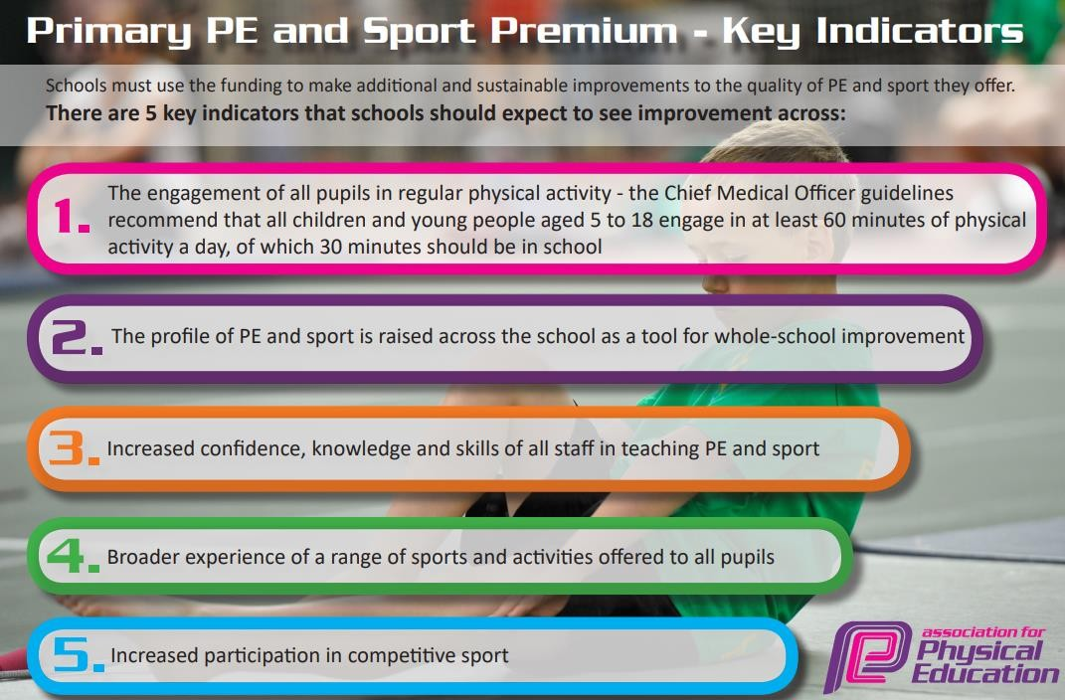

Review of last year’s spend and key achievements (2023/2024)
Activity/Action | Impact
Pupils engage in regular physical activity (30 minutes of physical activity a day in school).  - % of pupils achieving ARE in each area PE to increase from last year in every year group.  - % of lunchtime incidents decreases due to the engagement in lunchtime programme. | - External reviews demonstrate that lunchtimes are purposeful, and pupils are engaged in a range of activities. Lunchtime incidents are few; less than ten incidents per term involving inappropriate language, physical altercations, or child on child physical abuse).  - All classes are now taking part in 2 x PE sessions per week; one led by the sports coach and one taught by the class teacher using Get Set 4 PE.  - Morning activities club introduced for parents and pupils focusing on running, walking, ball games, exercise routines, dancing. Parental feedback has been overwhelmingly positive on this.  - Interventions around managing feelings and sensory circuits are all focused on movement; boxing, circuits, power up, running.  - Recent staff training has focused on the link between exercise, mental health and retention of learning.  Next steps  - Track engagement numbers in clubs and morning activities.  - Disadvantaged pupils to be targeted for clubs.
Swimming -  Pupils leave Y6 being able to:  - Perform safe self-rescue in different water-based situations  - Swim competently, confidently and proficiently over a distance of at least 25 metres  - Use a range of strokes effectively, for example, front crawl, backstroke and breaststroke. | Kirklees data for Year 5  - Baseline- 10%  - Perform safe self-rescue in different water-based situations- 22%  - Swim competently, confidently and proficiently over a distance of at least 25 metres- 66%  - Use a range of strokes effectively, for example, front crawl, backstroke and breaststroke- 41%  Next steps  - Further analysis of swimming data to provide further support for those pupils who need it.
The profile of PE and sport is being raised across the school as a tool for whole school improvement. | - New sports clubs/teams introduced; Cheerleading, Dancing, Cricket, Football- boys and girls, Gym/fitness club (girls only club available as well, as requested by pupils), Multi-sports for KS1, Multi-sport camps during summer break and May half-term.  - The school achieved Gold in the School Game Mark for the third year in a row.  Next steps  - Raise the profile of team sports by introducing trust tournaments for the primaries.
Increased confidence, knowledge and skills of all staff in teaching PE and sport. | - 100% of staff voice report increased levels of confidence and knowledge in teaching PE after working with SM Sports.  - Recent staff training has focused on the link between exercise, mental health and retention of learning. Staff are on board with this and are incorporating physically active brain breaks into their daily routines.  Next steps  - Focus on assessment of PE through the use of Get Set 4 PE MTPs.

Key Priorities and Planning |  | Sports Premium Amount: £18,450
Action – what are you planning to do | Who does this action impact? | Key indicator to meet | Impacts and how sustainability will be achieved? | Cost linked to the action
Improve the offer of extracurricular sporting activity (clubs/ teams/competitions/events):  - Continued partnership with external Sports Coaches to run multi sports-clubs and girls football club.  - Further develop the role of the Pastoral Support worker in the provision of the above.  - Strengthen the network across Share MAT primaries – collaboration between Pastoral Support Workers in the implementation of teams/competitions and events.  - Join and work with Pennine Sports to broaden the offer of sporting events/competitions | All pupils - through whole school events.  Pupils who show additional interest - through sign up to clubs/activities.  Pupils who show talent/enthusiasm to compete -through teams and competitions  PP pupils and girls to be targeted.  Vulnerable pupils (activity and health wise) to be targeted. | - 100% of primary pupils to participate in PE or healthy activity beyond normal PE lessons.  - At least 60% of pupils to agree that “I take part in school activities outside of lessons, such as sports”.  - Achieve the School Games Mark in Gold for the fourth year running (school to aim for platinum award after 5 years). | More availability of sporting activity for all – with broader focus.  Increased participation in sporting activity overall.  Talents being celebrated and catered for.  Extracurricular offer (after school, lunchtime and morning) to extend and further develop skillset in PE (when clubs are planned to enhance the PE long term plan). | % of cost of the SM Sports SLA: £10,000 (total £11,700)  % of PSW salary: £5000  Cost of vehicle hire (for events/ competitions): £800  Cost of resources for events and competitions: £500
Improve the quality of PE teaching:  - Join AfPE – resources, advice and guidance used to support good practice in PE.  - Broker support from Trust experts to better train PE leads to develop their subject  - Focus on subject plans and quality assurance/monitoring).  - Focused development sessions for PE leaders - observation of good practice (using examples from secondaries)  - Further embed ‘Get Set 4 PE’ scheme and assessment framework –  - Rework LTPs and implement MTPs – pick out Golden Knowledge per unit of PE  - Focus on curriculum coverage of health (including mental health)– link to Personal Development offer  - Further develop resourcing for each of the PE units.  - Protect time for PE leads to quality assure the subject and support teachers to get better through clear feedback and relevant support and training  - Utilise SM Sports in SEMH interventions for movement breaks, confidence building interventions.  - Use of SM Sports to train SEN TAs for physical activity interventions. | Teachers -  PE policy/procedure made clear.  Clarity in terms of expectations and subject knowledge.  Clearer understanding of ARE in each area of PE - resulting in accurate assessment and precision planning to narrow gaps in ability.  Support/CPD to better equip developments in PE teaching.  Pupils -  Better progress and attainment as a result of better-quality PE teaching, more engagement in regular physical activities, movement interventions for key pupils. | - More that 80% of teachers say that professional development has helped them to build confidence in PE  - More than 60% of pupils meet ARE in PE (when assessing against Golden Knowledge)  - Pupils can talk about their knowledge of PE when asked as part of QA.  - 70% of pupils agree that “My school encourages me to look after my physical health (for example healthy eating and fitness)”  - 70% to agree that “My school encourages me to look after my emotional and mental health”  - QA finds improvement in the quality of PE teaching, and whole school data. | Year 1 of a longer development project – linking to Trust aims to ensure all pupils know and remembering more across the curriculum – all staff valuing the notion that physical activity positively impacts brain function – particularly the functionality of the long-term-memory (linked to the science of learning).  PE will be factored into Trust and School improvement planning this year and over the next two years. | Cover costs for PE leads for leadership development work: £1000- already accounted for in PP plan  AfPE subscription: £150  Get Set 4 PE Scheme:  £467.50  PE unit resources:  £300  SM Sport involvement costed above.
Improve the provision of physical activity during social times:  - Purchase high quality play equipment to resource lunch/break time provision.  - Further develop the role of Play Leaders.  - Further develop lunchtime staff knowledge of lunchtime group activities, and their confidence in leading these. | Pupils – increased participation in physical activity helping them to be successful more broadly (brain function/ mental health and wellbeing).  Play Leaders– leadership skills develop.  Staff/school leader/pupils – reduction in behavioral incidents due to the focus on organised/purposeful activity. | - 100% of primary pupils participate in healthy activity beyond normal PE lessons.  - Behaviour incidents during social times to be low in comparison to previous years.  - Children better prepared to learn – as indicated by attainment and progress data | Pupils familiar with developing leadership/organisational skills – younger pupils' aspirant for the role.  Behaviour/first aid incidents during social time to remain low.  Ways of working and being well resourced will aid outstanding provision during social times to be the norm moving forward. | Cost of play provision equipment: £1000  Cost of playground Play Leader resources: £200
Raise the profile of physical activity/PE:  - Introduce Sports Aspiration Assemblies | Pupils and staff – motivation gained from listening to the successes and inspirational elements of guest speakers from various sporting fields. | See KPIs from previous points. | Create network/connections so guest speakers come to speak regularly – this becomes part of our base offer for PE
 |  |  | Total | £18417,50

Key Achievements 24-25
Activity/Action | Impact | Comments

Swimming Data
Question | Stats:
What percentage of your current Year 5 cohort can swim competently, confidently and proficiently over a distance of at least 25 metres? | Swimming starts in Spring 1 term for 2024-2025  2023-2024  - Baseline- 10%  - Swim competently, confidently and proficiently over a distance of at least 25 metres- 66%
What percentage of your current Year 5 cohort can use a range of strokes effectively [for example, front crawl, backstroke, and breaststroke]? | 2023-2024  41%
What percentage of your current Year 5 cohort can perform safe self-rescue in different water-based situations? | 2023-2024  22%
If your schools swimming data is below national expectation, you can choose to use the Primary PE and sport premium to provide additional top-up sessions for those pupils that did not meet National Curriculum requirements after the completion of core lessons. Have you done this? | 2023-2024  No
Have you provided CPD to improve the knowledge and confidence of staff to be able to teach swimming and water safety? | 2023-2024  Provided by KAL swim team

Signed off by:
Head Teacher: | Rhona Pleasant
Subject Leader or the individual responsible for the Primary PE and sport premium: | Karli Dransfield and Lauren Wyke
Governor: | Vic White
Date: | 05.11.24

