



Millbridge Primary Academy
PE/Sport Premium Plan
2025 – 2026



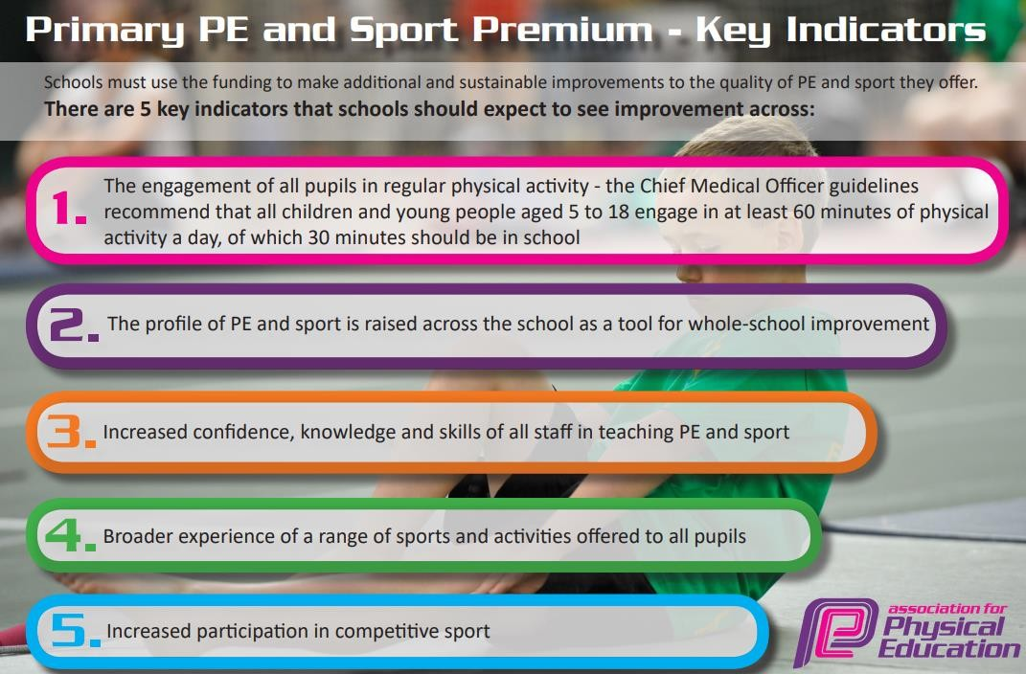

Review of last year’s spend and key achievements (2024/2025)
Activity/Action | Impact
Improve the offer of extracurricular sporting activity (clubs/ teams/competitions/events). | The number of extra-curricular sporting opportunities has increased significantly. We now have two football teams (LKS2 and UKS2) and they compete regularly with local schools and train weekly to improve their skills and resilience. Disadvantaged pupils are targeted initially through invite to a club.  Lunchtime clubs and activities are led well by playleaders. There is a range of activities on offer daily; running, boot camp, tag games, football, skipping and dancing.  100% of pupils agreed with the statement ‘School encourages me to look after my physical health (for example, healthy eating and fitness)’ in our most recent Pupil Survey.  73% of pupils agreed with the statement ‘I take part in school activities outside of lessons, like clubs, sports, music and art.’
Improve the quality of PE teaching. | Using weekly in lesson support from SM Sports, teachers benefit from weekly coaching in PE lessons to further improve the quality of PE teaching.  Recent Trust training has also focused on pupil participation and optimising the amount of ‘active’ time in lessons.  Pupil voice demonstrates that they remember the skills and knowledge taught in PE lessons. They are able to articulate the small steps of PE skills, and how much they enjoy PE.  All pupils receive two hours of PE per week, as well as more physical activities available during lunchtimes.  The Pastoral Support Worker also works with every class daily for a Fit 15 session.
Improve the provision of physical activity during social times. | Lunchtime clubs and activities are led well by playleaders. There is a range of activities on offer daily; running, boot camp, tag games, football, skipping and dancing.  As a result of this, behaviour incidents at lunchtime are few.  97% of pupils agreed with the statement ‘Behaviour of other pupils around school is good’ in our most recent Pupil Survey.

Key Priorities and Planning |  | Sports Premium Amount: £18,360
Action – what are you planning to do | Who does this action impact? | Key indicator to meet | Impacts and how sustainability will be achieved? | Cost linked to the action
Improve the offer of extracurricular sporting activity (clubs/ teams/competitions/events):  - Continued partnership with external Sports Coaches to run multi sports-clubs and girls football club.  - Further develop the role of the Pastoral Support worker in the provision of the above.  - Strengthen the network across Share MAT primaries – collaboration between Pastoral Support Workers in the implementation of teams/competitions and events.  - Join and work with Pennine Sports to broaden the offer of sporting events/competitions | All pupils - through whole school events.  Pupils who show additional interest - through sign up to clubs/activities.  Pupils who show talent/enthusiasm to compete -through teams and competitions  PP pupils and girls to be targeted.  Vulnerable pupils (activity and health wise) to be targeted. | - 100% of primary pupils to participate in PE or healthy activity beyond normal PE lessons.  - At least 60% of pupils to agree that “I take part in school activities outside of lessons, such as sports”.  - Achieve the School Games Mark in Gold for the fifth year running (school to aim for platinum award after 5 years). | More availability of sporting activity for all – with broader focus.  Increased participation in sporting activity overall.  Talents being celebrated and catered for.  Extracurricular offer (after school, lunchtime and morning) to extend and further develop skillset in PE (when clubs are planned to enhance the PE long term plan). | % of cost of the SM Sports SLA: £9,360  % of PSW salary: £5000  Cost of vehicle hire (for events/ competitions): £800  Cost of resources for events and competitions: £500
Improve the quality of PE teaching:  - Continue to use AfPE – resources, advice and guidance used to support good practice in PE.  - Broker support from Trust experts to better train PE leads to develop their subject  - Focus on subject plans and quality assurance/monitoring).  - Focused development sessions for PE leaders - observation of good practice (using examples from secondaries)  - Further embed ‘Get Set 4 PE’ scheme and assessment framework –  - Rework LTPs and implement MTPs – pick out Golden Knowledge per unit of PE  - Focus on curriculum coverage of health (including mental health)– link to Personal Development offer  - Further develop resourcing for each of the PE units.  - Protect time for PE leads to quality assure the subject and support teachers to get better through clear feedback and relevant support and training  - Utilise SM Sports in SEMH interventions for movement breaks, confidence building interventions.  - Use of SM Sports to train SEN TAs for physical activity interventions. | Teachers -  PE policy/procedure made clear.  Clarity in terms of expectations and subject knowledge.  Clearer understanding of ARE in each area of PE - resulting in accurate assessment and precision planning to narrow gaps in ability.  Support/CPD to better equip developments in PE teaching.  Pupils -  Better progress and attainment as a result of better-quality PE teaching, more engagement in regular physical activities, movement interventions for key pupils. | - More that 80% of teachers say that professional development has helped them to build confidence in PE  - More than 60% of pupils meet ARE in PE (when assessing against Golden Knowledge)  - Pupils can talk about their knowledge of PE when asked as part of QA.  - 70% of pupils agree that “My school encourages me to look after my physical health (for example healthy eating and fitness)”  - 70% to agree that “My school encourages me to look after my emotional and mental health”  - QA finds improvement in the quality of PE teaching, and whole school data. | Year 1 of a longer development project – linking to Trust aims to ensure all pupils know and remembering more across the curriculum – all staff valuing the notion that physical activity positively impacts brain function – particularly the functionality of the long-term-memory (linked to the science of learning).  PE will be factored into Trust and School improvement planning this year and over the next two years. | Cover costs for PE leads for leadership development work: £1000- already accounted for in PP plan  AfPE subscription: £160  Get Set 4 PE Scheme:  £447  PE unit resources:  £300  SM Sport involvement costed above.
Improve the provision of physical activity during social times:  - Purchase high quality play equipment to resource lunch/break time provision.  - Further develop the role of Play Leaders.  - Further develop lunchtime staff knowledge of lunchtime group activities, and their confidence in leading these. | Pupils – increased participation in physical activity helping them to be successful more broadly (brain function/ mental health and wellbeing).  Play Leaders– leadership skills develop.  Staff/school leader/pupils – reduction in behavioral incidents due to the focus on organised/purposeful activity. | - 100% of primary pupils participate in healthy activity beyond normal PE lessons.  - Behaviour incidents during social times to be low in comparison to previous years.  - Children better prepared to learn – as indicated by attainment and progress data | Pupils familiar with developing leadership/organisational skills – younger pupils' aspirant for the role.  Behaviour/first aid incidents during social time to remain low.  Ways of working and being well resourced will aid outstanding provision during social times to be the norm moving forward. | Cost of play provision equipment: £1500  Cost of playground Play Leader resources: £300
Raise the profile of physical activity/PE:  - Introduce Sports Aspiration Assemblies | Pupils and staff – motivation gained from listening to the successes and inspirational elements of guest speakers from various sporting fields. | See KPIs from previous points. | Create network/connections so guest speakers come to speak regularly – this becomes part of our base offer for PE
 |  |  | Total | £18,367

Swimming Data 24-25
Question | Stats:
What percentage of your current Year 5 cohort can swim competently, confidently and proficiently over a distance of at least 25 metres? | Start of swimming lessons- 9%  End of swimming lessons- 60%
What percentage of your current Year 5 cohort can use a range of strokes effectively [for example, front crawl, backstroke, and breaststroke]? | 44%
What percentage of your current Year 5 cohort can perform safe self-rescue in different water-based situations? | 16%
If your schools swimming data is below national expectation, you can choose to use the Primary PE and sport premium to provide additional top-up sessions for those pupils that did not meet National Curriculum requirements after the completion of core lessons. Have you done this? | Yes- however, there are no available sessions at the local swimming pool.
Have you provided CPD to improve the knowledge and confidence of staff to be able to teach swimming and water safety? | Yes- this now features in the PSHE curriculum.

Signed off by:
Head Teacher: | Rhona Pleasant
Subject Leader or the individual responsible for the Primary PE and sport premium: | Karli Dransfield and Lauren Wyke
Governor: | Vic White
Date: | 08.12.25

