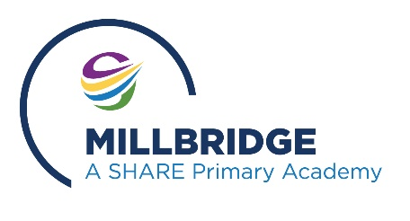

How to Access Remote Learning on Playstation/ Xbox
If you haven’t got a laptop/ tablet to access remote learning but do have a Playstation or Xbox, please follow the steps below to bring up your remote learning tasks on your console:

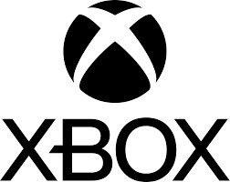

- Plug a keyboard into the Xbox USB slot;
- Go to my games and apps;
- Find and select Microsoft Edge;
- In the address bar, type in Class Dojo student (or Tapestry for Foundation children); 5. Login to your account using the details provided by school.
- Identify the PlayStation internet browser icon (WWW with dots around it);
- Press the PlayStation logo on the controller;
- Go to the library and find options for games and applications;
- Go to applications and you will find the internet browser;
- In the address bar, type in Class Dojo student (or Tapestry for Foundation children);
- Login to your account using the details provided by school.

